BCD to Seven Segment Decoder

LAB # 05



Spring 2024
CSE-308L Digital System Design Lab

Submitted by: Ali Asghar
Registration No.: 21PWCSE2059
Class Section: C

“On my honor, as student of University of Engineering and Technology, I have neither given nor received unauthorized assistance on this academic work.”

Submitted to:
Dr. Asif Ali Khan

Date:
29th March 2024

Department of Computer Systems Engineering
University of Engineering and Technology, Peshawar
Objectives:
This lab will enable students to:
- To implement a BCD to Seven Segment Decoder on Spartan 6 board.

Software used:
- Xilinx ISE

Task 1:
Using switches enter a BCD number and show the resulting number on the seven segment display.

Code:
DUT:
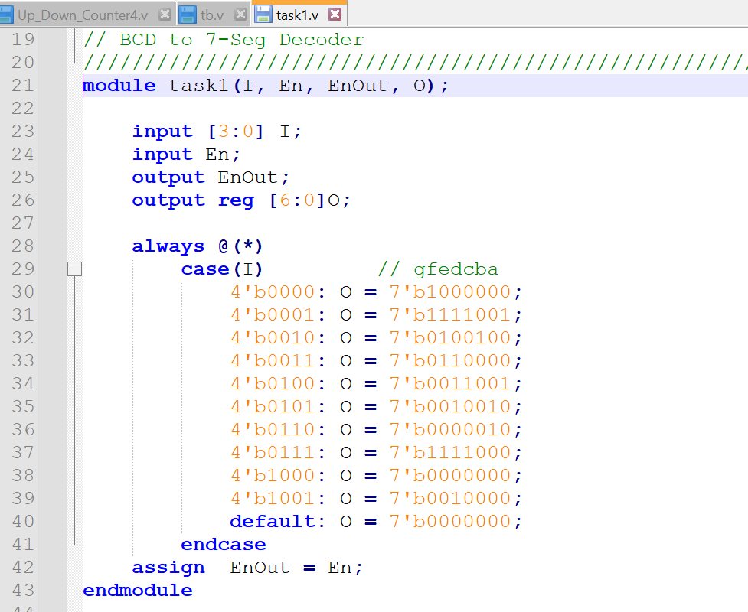
ucf file:
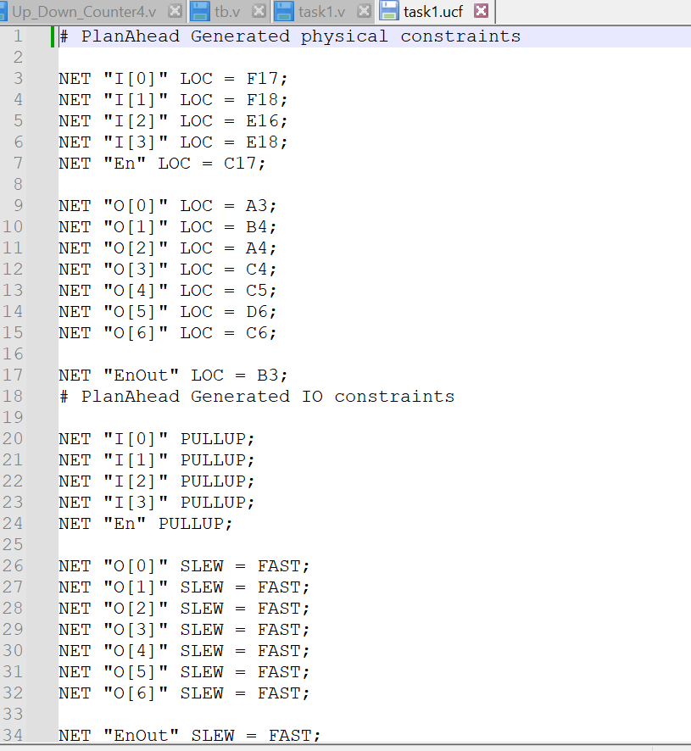

Output:
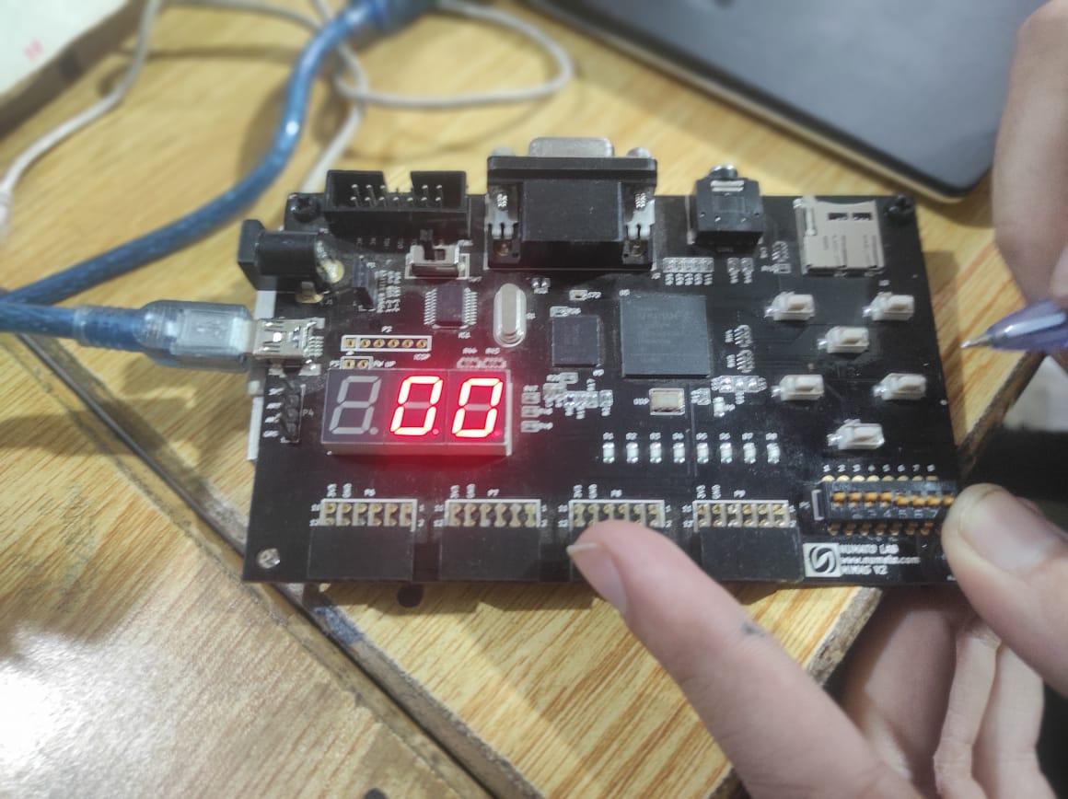
I[3]
I[1]
I[2]
I[0]
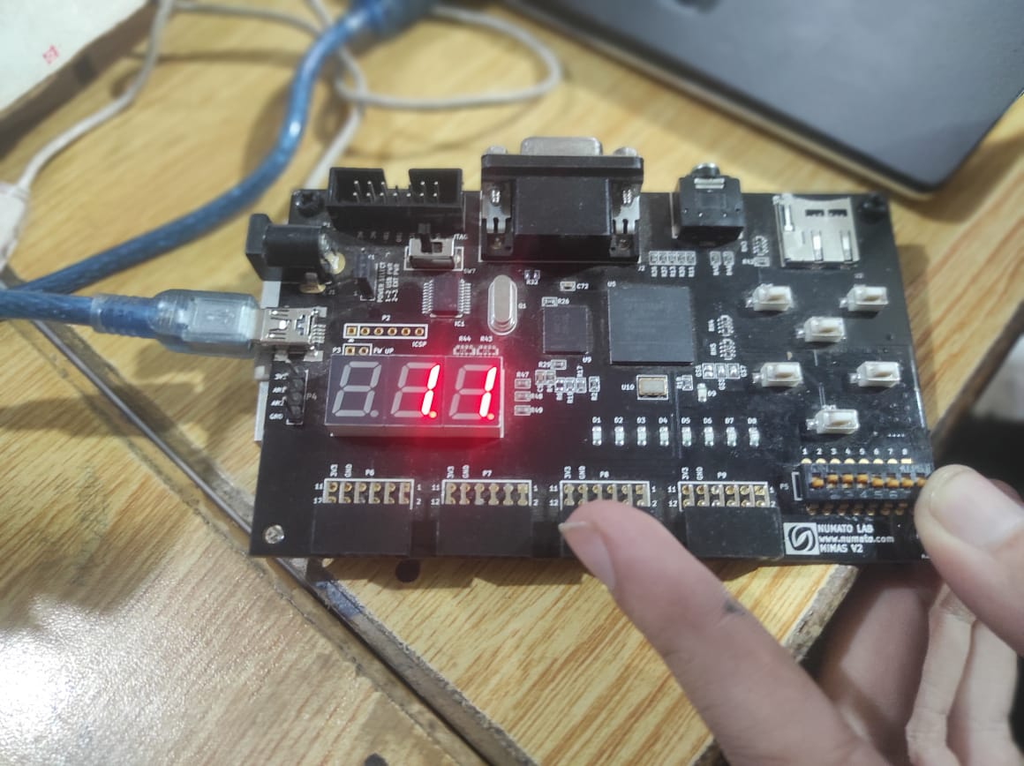

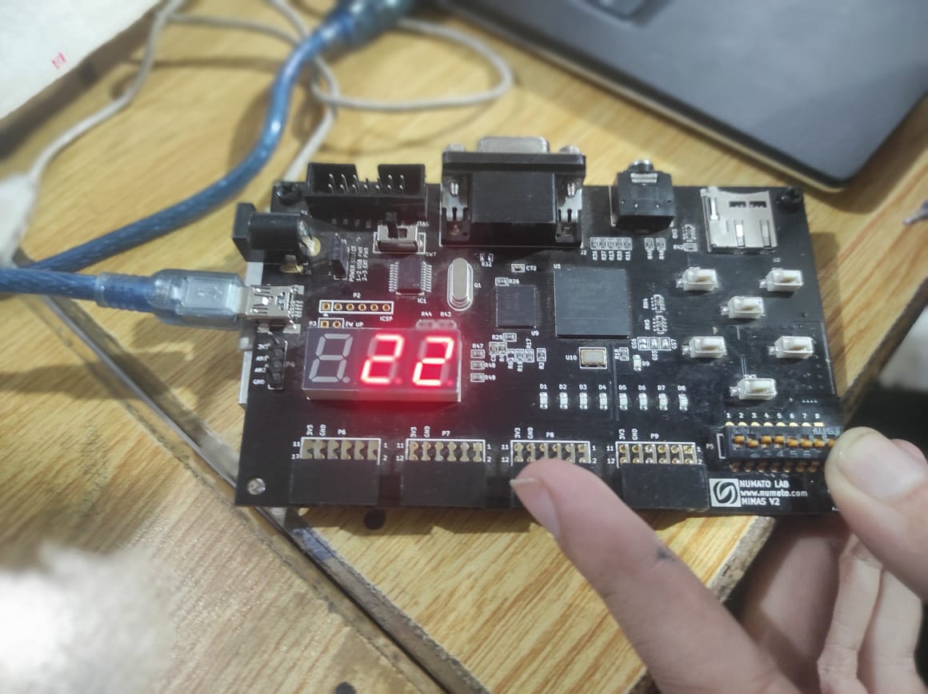
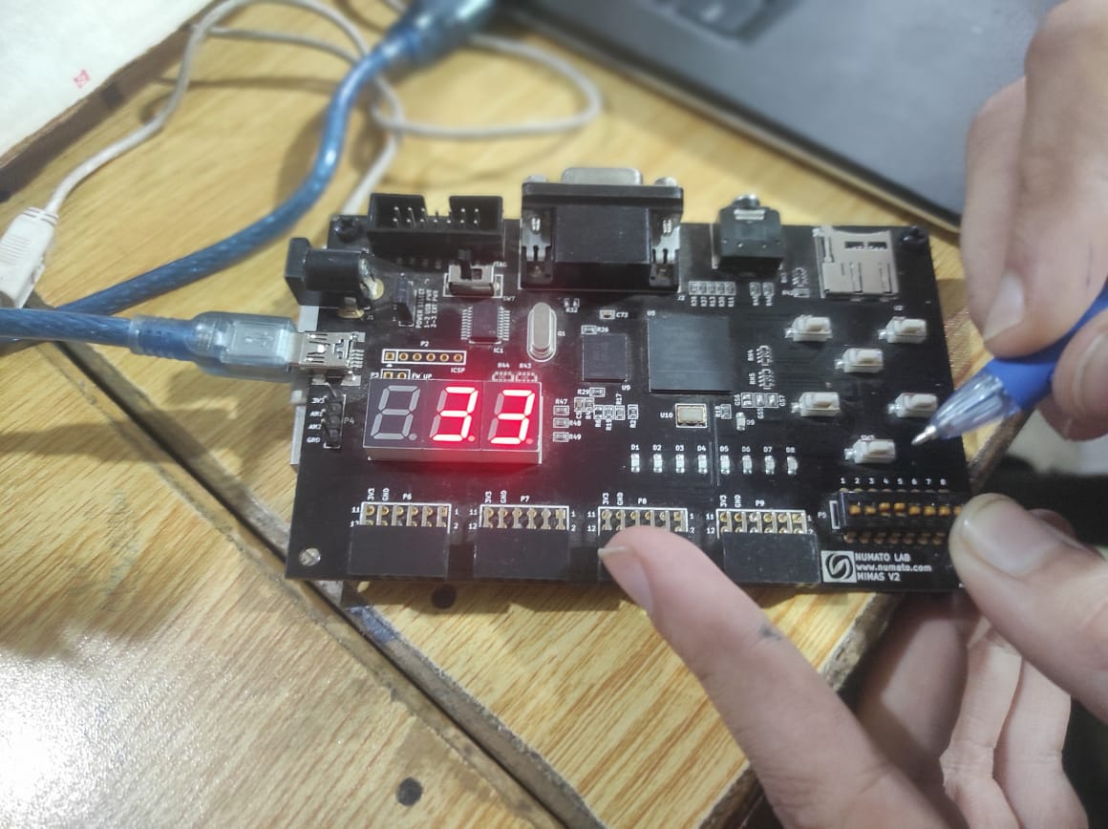

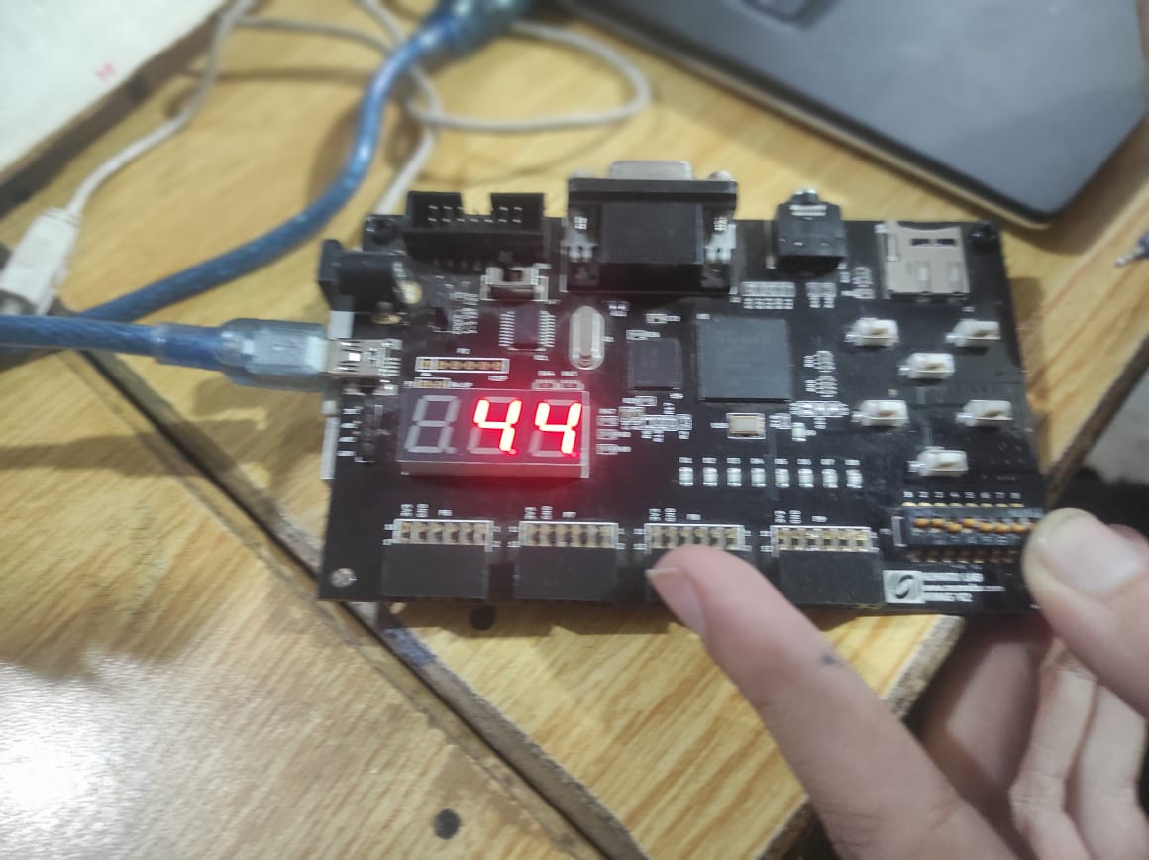
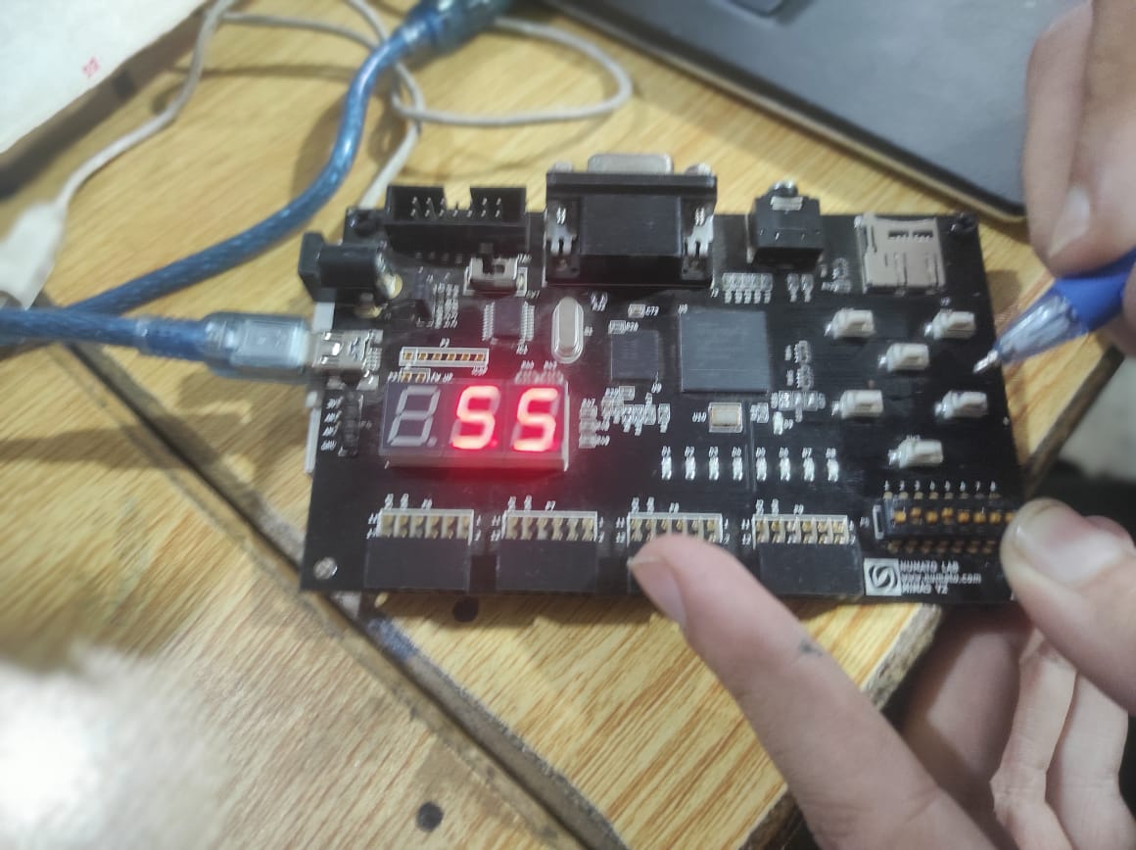
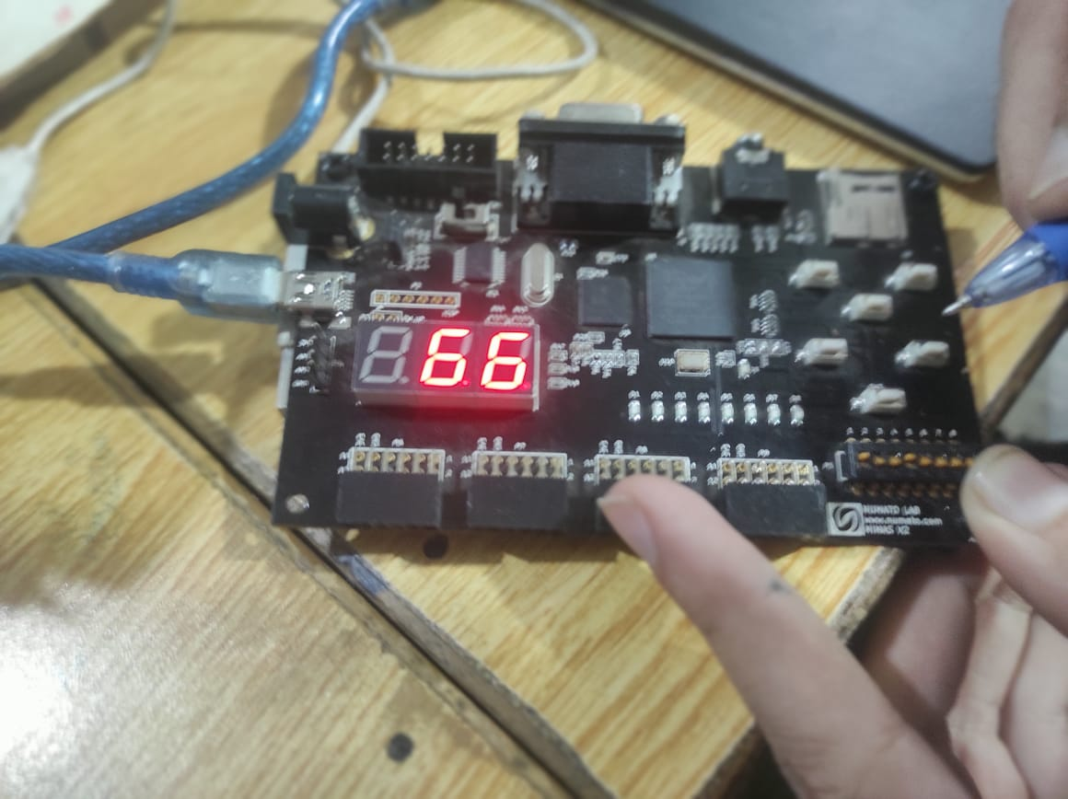

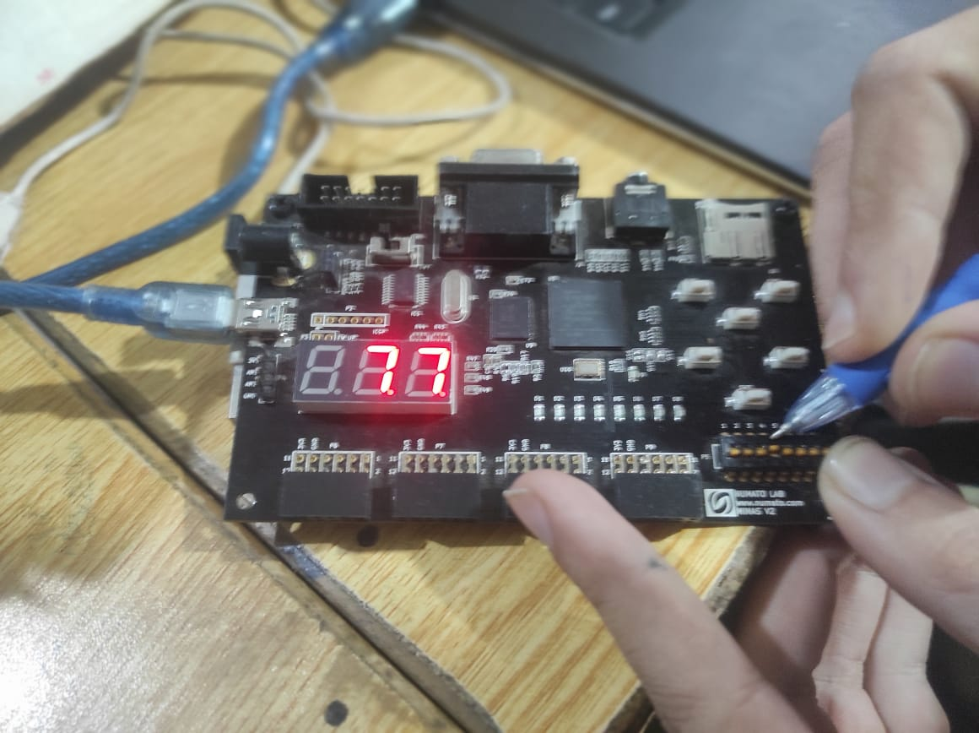
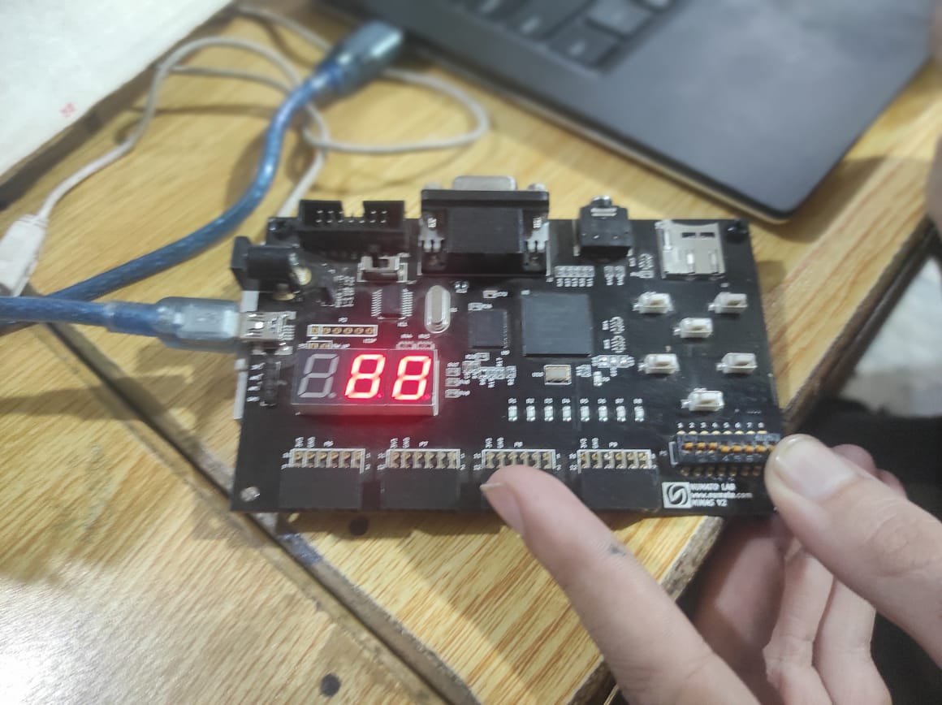
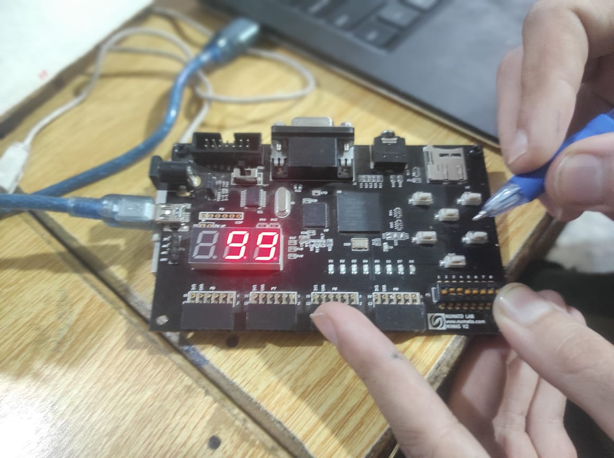

Task 2:
Connect the output of your lab 02 (4 bit adder) to the seven segment display. Note that number above 1001 are not valid BCD numbers. In this situation keep the seven segment display off and just the dp on.

Code:
DUT:
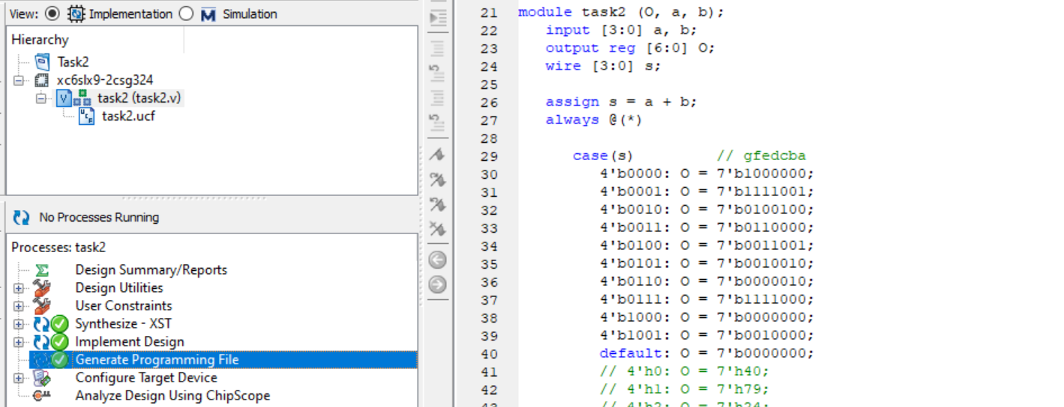
ucf file:
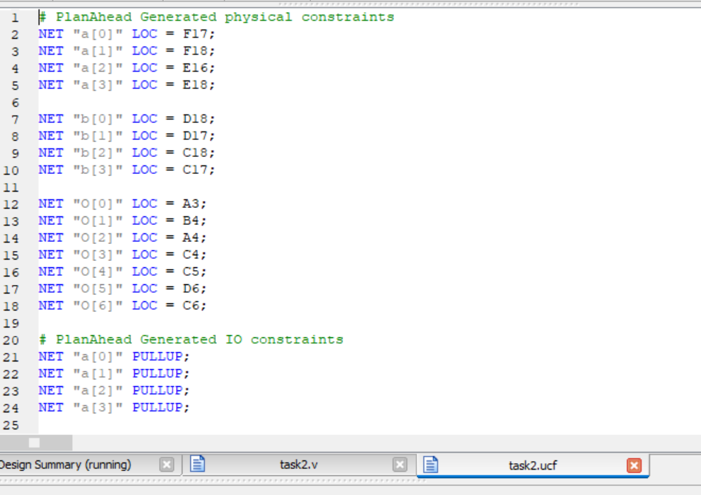
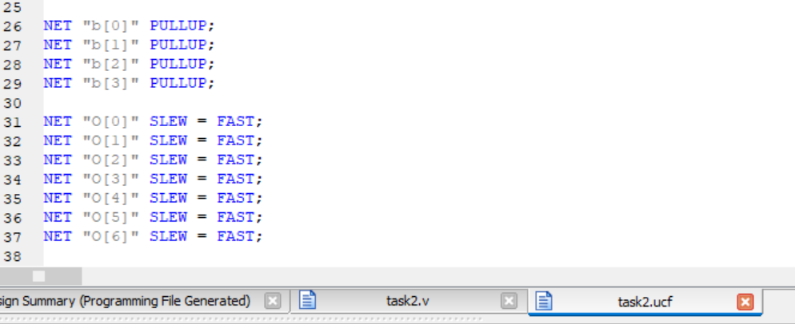

Output:
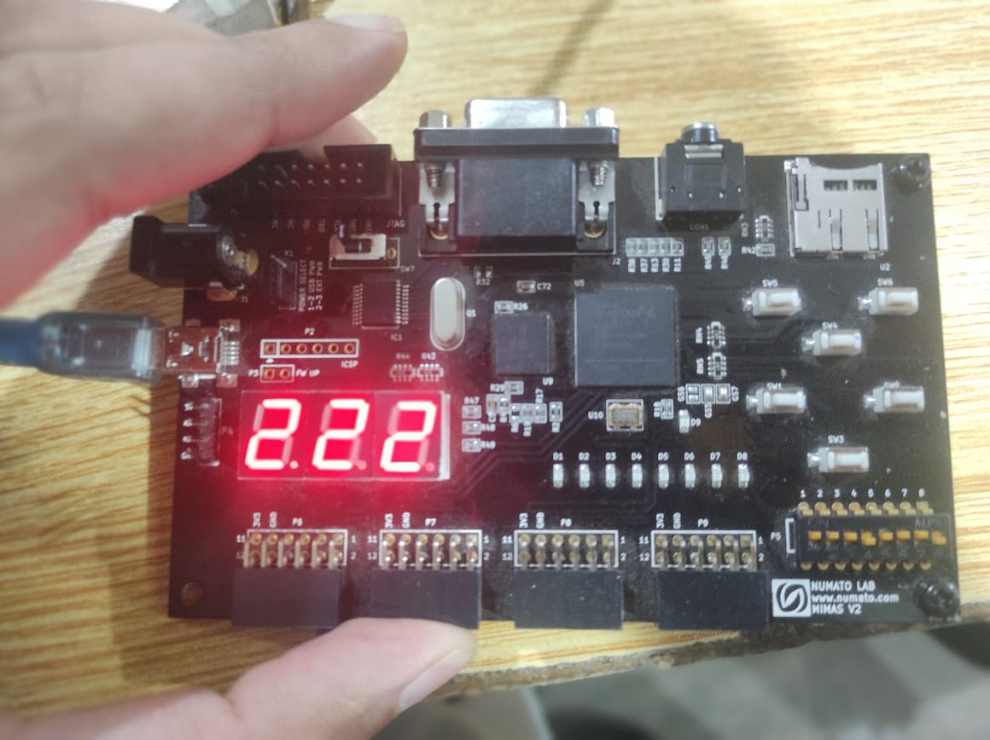
b[0]
b[1]
b[2]
b[3]
a[3]
a[1]
a[2]
a[0]
